<https://github.com/dwaipayan-code/task_tracker/blob/main/README.md>

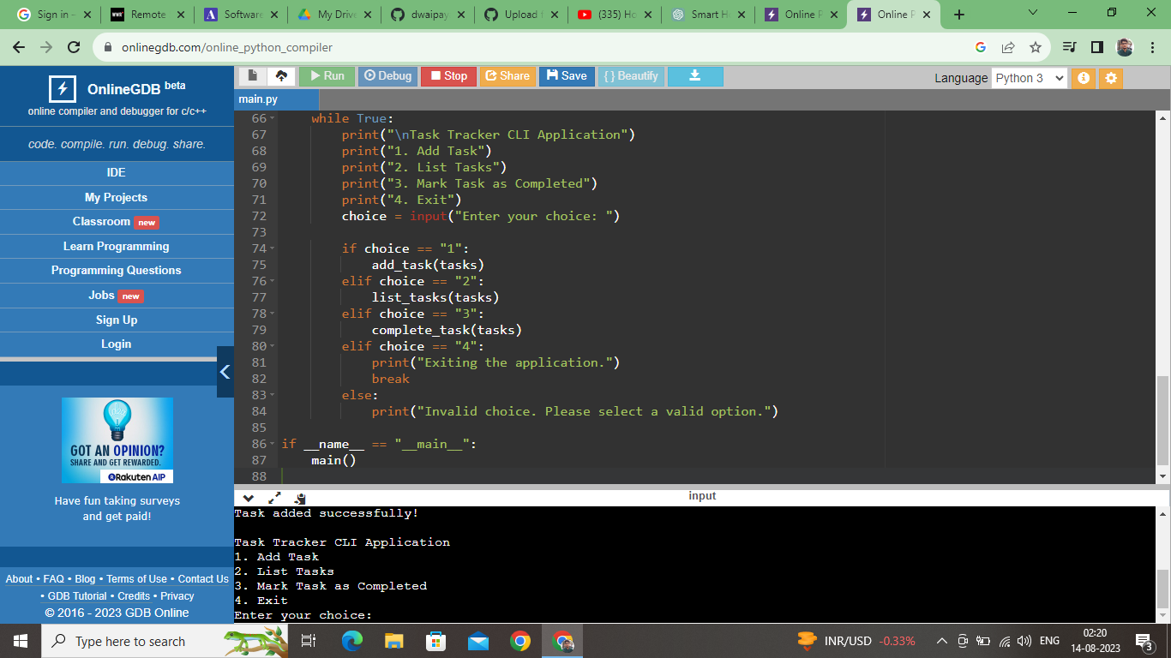

import os

import json

from datetime import datetime

# File to store tasks

TASKS_FILE = "tasks.json"

# Load tasks from file

def load_tasks():

if os.path.exists(TASKS_FILE):

with open(TASKS_FILE, "r") as file:

return json.load(file)

return []

# Save tasks to file

def save_tasks(tasks):

with open(TASKS_FILE, "w") as file:

json.dump(tasks, file, indent=4)

# Add a new task

def add_task(tasks):

task_name = input("Enter task name: ")

priority = input("Enter task priority (low, medium, high): ").lower()

due_date = input("Enter due date (YYYY-MM-DD): ")

tasks.append({

"name": task_name,

"priority": priority,

"due_date": due_date,

"completed": False

})

save_tasks(tasks)

print("Task added successfully!")

# List all tasks

def list_tasks(tasks):

for index, task in enumerate(tasks, start=1):

status = "Completed" if task["completed"] else "Pending"

print(f"{index}. {task['name']} (Priority: {task['priority']}, Status: {status})")

# Mark a task as completed

def complete_task(tasks):

list_tasks(tasks)

task_index = int(input("Enter the index of the task to mark as completed: ")) - 1

if 0 <= task_index < len(tasks):

tasks[task_index]["completed"] = True

save_tasks(tasks)

print("Task marked as completed!")

else:

print("Invalid task index.")

# Main function

def main():

tasks = load_tasks()

while True:

print("\nTask Tracker CLI Application")

print("1. Add Task")

print("2. List Tasks")

print("3. Mark Task as Completed")

print("4. Exit")

choice = input("Enter your choice: ")

if choice == "1":

add_task(tasks)

elif choice == "2":

list_tasks(tasks)

elif choice == "3":

complete_task(tasks)

elif choice == "4":

print("Exiting the application.")

break

else:

print("Invalid choice. Please select a valid option.")

if __name__ == "__main__":

main()